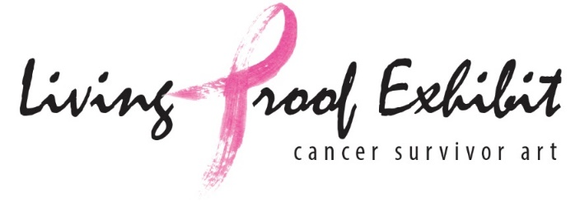
2018-2019 Solicitation Fundraising Internship
Living Proof Exhibit provides the therapeutic benefits of the arts to people impacted by cancer: cancer patients, survivors, and those who love them. We do this by teaching regular art sessions, hosting exhibitions, distributing art-to-go projects, and providing virtual tours of the Figge Art Museum.
Living Proof Exhibit seeks an intern who will promote the organization's mission through cohesive social media messaging, raise money using a micro campaign on Facebook, and assist in other stewardship activities
This organization encourages innovative ideas. If you intern with Living Proof Exhibit, you will become a vital member of a dynamic team; as such, your ideas will directly impact the organization's mission and growth.
As an intern, you will:
- Create cohesive messaging throughout our social media platforms and between social media and our website
- Create and implement a Facebook micro campaign
- Work with donor database to update and increase donors
- Assist in developing other stewardship strategies and methodology including social media and website
This position requires:
- Exceptional writing skills
- Professional social media skills
- A creative thinker
- Someone adept at independent work who will meet required deadlines
The intern will work closely with the executive director as well as marketing and fundraising professionals on the board of directors.
The position begins October 1, 2018 and runs through December 10, 2018 with an average of 5-7 hours/week. It will pay a stipend of $600.
To apply please send your resume and cover letter to Pamela at livingproofexhibit@gmail.com

