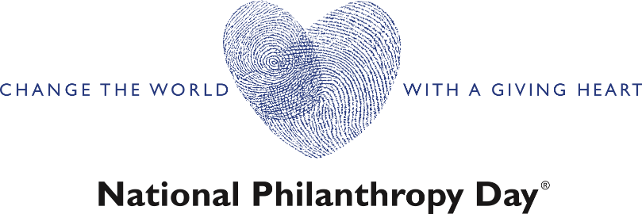

The Association of Fundraising Professionals Quad Cities (AFP-QC) hosts an annual awards presentation in honor of National Philanthropy Day. National Philanthropy Day is a special day set aside on the fifteenth of November. The purpose of this day is to recognize the great contributions of philanthropy and those people active in the philanthropic community—to the enrichment of the Quad Cities region.

We have honored many distinguished people, businesses, and organizations year after year, here are a few award winners from the past few years:

* Distinguished Service to Philanthropy—**James and Carol Horstmann**
* Outstanding Philanthropist—**Linda Bowers**
* Outstanding Volunteer Fundraiser—**Frank Clark**
* Outstanding Foundation—**John Deere Foundation**
* Outstanding Planned Giving Professional—**Steve Goebel**
* Outstanding Fundraising Executive—**Kimberly Findlay**
* Outstanding Civic/Service Organization, Corporation, Corporate Foundation, or Foundation— **Ascentra Credit Union- Linda Andry, CEO**
* Outstanding Philanthropist or Charitable Family—**Heidi Huiskamp-Collins**
* Outstanding Volunteer Fundraiser— **Dr. Joe and Ann Lohmuller**
* Outstanding Youth Group— **Teens for Tomorrow**
* Outstanding Planned Giving Professional—**Tom Hammar**
* Outstanding Charitable Family — **Donna and Paul VanDuyne**
* Outstanding Planned Giving Professional—**David Nelson**
* Outstanding Foundation- **Regional Development Authority**

Society is putting a much greater demand on companies to behave in more socially responsible ways – be it the environment, supporting local communities or championing equality/diversity. National Philanthropy Day with AFP-QC recognizes those who are the embodiment of social responsibility.

Our attendees for the event include corporate executives, non-profit leadership, past philanthropists, board members, employees, and families, they are all there to express their gratitude and support. As a sponsor of this celebration of generosity you will be showcased to our pillars in the community, business owners and staff, and the media.

**Event Snapshot:**

National Philanthropy Day hosted by AFP-QC

Wednesday, November 15, 2023

Rhythm City Casino and Hotel

Doors open 6:30pm

An evening of celebrating those in the Quad Cities community whose charitable work, philanthropic endeavors, and innovative generosity inspired many in 2023.

Both award winners and nominees will be showcased.

Cocktails and hors d’hoeuvres

AFP-QC is seeking businesses to sponsor our awards event and highlight their philanthropic culture in collaboration with our pursuit of elevating those in our community who need the non-profit services the most.

**Sponsor Opportunities**

**Presenting Sponsor: $3,000**

* Recognition as presenting sponsor in all public relations materials such as social media, collateral, website event page, and e-blasts to membership
* Banner on stage and at the entrance to event
* The ability to provide a short sponsor highlight speech to attendees
* Provide swag at each table setting
* Complimentary table of eight

**Benevolent Sponsor: $2,000**

* Recognition in the program, collateral, website event page, and e-blasts to membership
* Banner at entrance to event
* Provide swag at each table setting
* 4 Complimentary tickets

**Altruistic Sponsor: $1,000**

* Recognition on website event page, and e-blasts to membership
* 2 complimentary tickets

___ Yes! I want to be a part of National Philanthropy Day on November 15, 2023 and sponsor at this level:

____ Presenting Sponsor: $3,000

____ Benevolent Sponsor: $2,000

____ Altruistic Sponsor: $1,000

**Sponsorship deadline is September 18th.**

Please send my company an invoice to:

Company:

Authorized Representative:

Address: City: Zip:

Phone:

Email:

______________________________________

Signature Date

Please sign and return to Sara Morby, NPD Chair at [smorby@figgeartmuseum.org](mailto:smorby@figgeartmuseum.org) or call 563-345-6642

On behalf of our Members and Board of Directors of AFP-QC – THANK YOU!!!